Specialist Mathematics Units 3 & 4
Test 3 2017
Calculator Free Section

Name: __________________________ Score: _____ / 28

No calculators or notes are to be used.
Access to approved Mathematics Specialist formulae sheet is permitted.
Simplify answers where possible. Time limit = 30 minutes.

1. [ 5 marks ]
Points A (-1, 2, 3), B (x, y, -1) and C (14, -4, -9) are collinear. Determine the values of x and y, and state the vector equation of this line.

2. [ 5 marks ]

Find the vector equation of the plane in the form r.n = k passing through the lines with equation:

r = <1,1,1> + <2,7,1> and r = <4-, 2+7, 7-3>

3. [ 3 marks ]

State the Cartesian equation traced by the point P with position vector r = t ² i + t j, where t represents time. Sketch the path on the axes below, indicating the direction of motion.

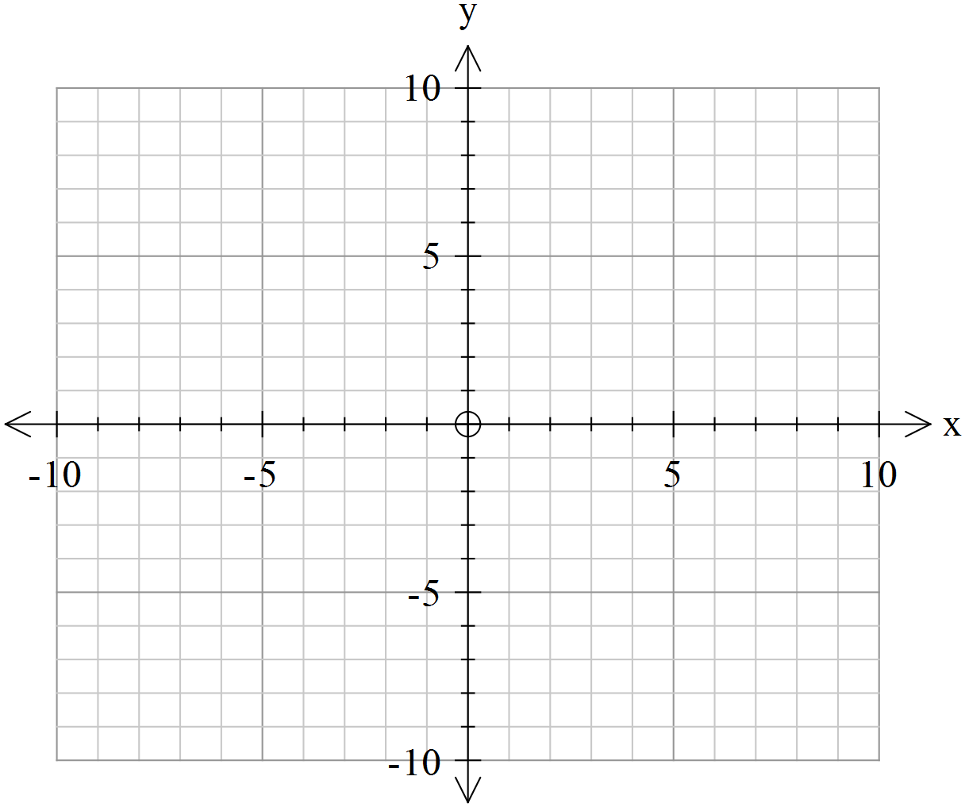

4. [ 9 marks: 4, 1, 1, 2 ]

Determine the possible values of m so that the following system of equations has
a) a unique solution,
b) no solution,
c) or more than one solution.
2x + y - z = 3
mx - 2y + z = 1
x + 2y + mz = -1

d) Using geometric planes, sketch and/or describe two different situations where a system of linear equations will have no solutions.

5. [ 3 marks ]

State the vector equation of the sphere with the Cartesian equation

6. [ 3 marks ]
Prove the property:
“If a and b are non-zero vectors then a x b = 0 means a is parallel to b.”

END OF PAPER
Specialist Mathematics Units 3 & 4
Test 3 2017
Calculator Section

Name: _______________________ Score: _____ / 29

Calculators allowed and 1 page of A4 notes, writing on both sides.
Access to approved Mathematics Specialist formulae sheet is permitted. Time limit = 30 minutes

7. [ 7 marks: 4, 3 ]

a) Determine the position vector of the point where the line meets the plane .

b) Determine the angle between the line and the plane in degrees to 1 decimal place.

8. [ 6 marks ]

Two rockets are moving at a constant velocity in straight lines. The first starts at (2, 2, 1) and has velocity (3, -1, -7) and the second has velocity (2, 1, -5), starting from (2, -3, 2). Show whether their paths cross and determine if they collide.
Give the coordinates of the point of crossing or collision.

9. [ 7 marks ]

In order to bring about a prison break a grappling hook is fired from a crossbow from a position level with the base of a wall 500m away. Two-and-a-half seconds later the grappling hook just clears the wall. If the wall is 6 m high, calculate the initial velocity to the nearest m/s and the projection angle of the ball-bearing to the nearest degree.
Assume gravity to be 9.8 m/s². It may help to draw a diagram first.

10. [ 9 marks: 2, 2, 2, 3 ]

The velocity vector of a particle P, at time t seconds after projection from < 0, 0, 0 > is given by v(t) = < t -1, 0, t – t ² > where the components are measured in cms⁻¹.

a) Determine when P is instantaneously at rest.

b) Calculate the distance travelled by P between the time it starts moving and when it is instantaneously at rest.

c) What is its position when it comes to rest ?

d) Determine when, if ever, the velocity is perpendicular to the acceleration.

END OF TEST

